**Guided Capstone Project Report**

We were tasked to predict Average Ticket Price for Big Mountain Resort based on it market segment. Present ticket price is $81.00.

Following features came up as important in our modeling:

* vertical_drop
* Snow Making_ac
* total_chairs
* fastQuads
* Runs
* LongestRun_mi
* trams
* SkiableTerrain_ac

ere aHere are some charts which represent these features and the relative position of Big Mountain Resort.

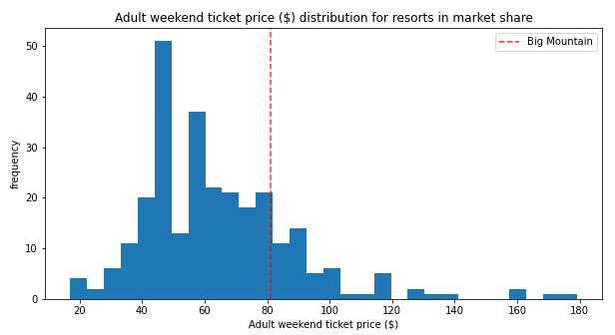

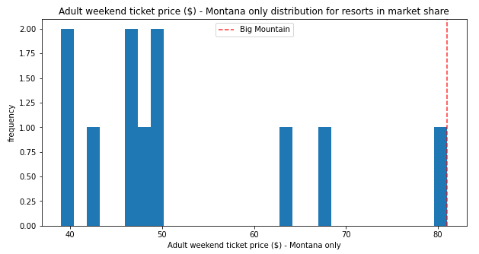

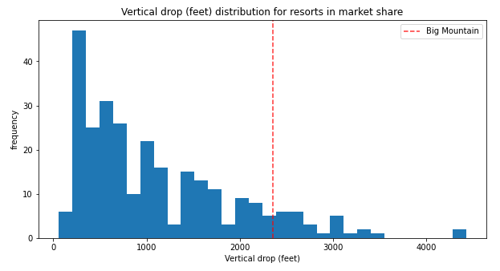

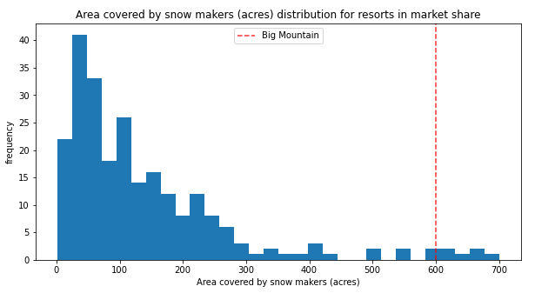

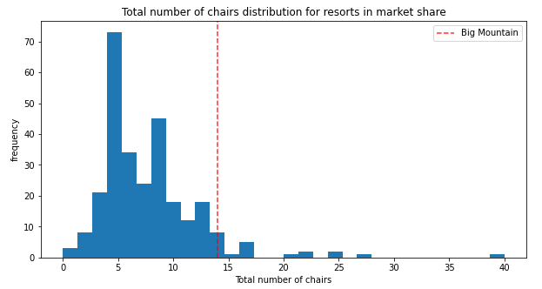

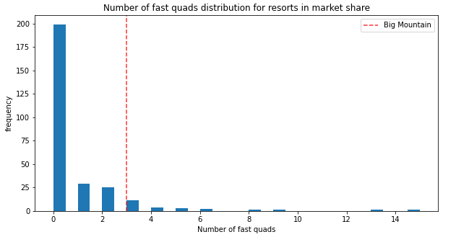

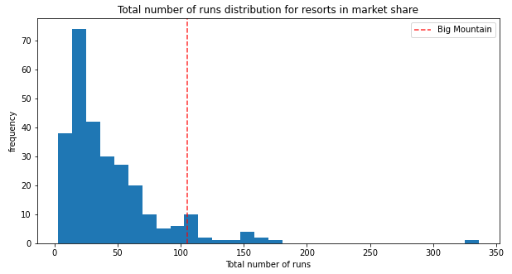

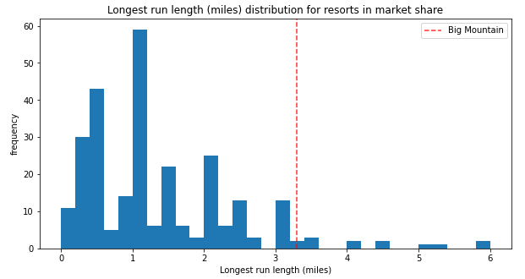

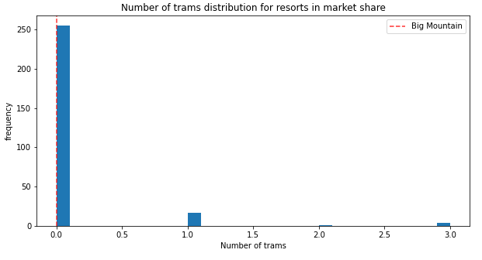

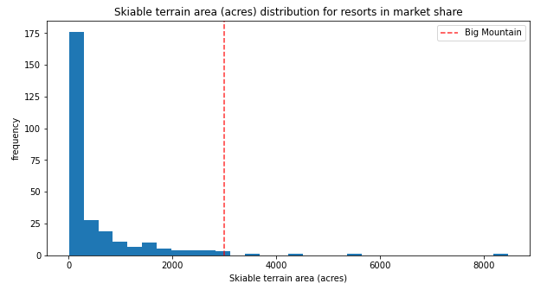

Big Mountain exceeds in most features in its market segment. **Based on this our model predicts that Big Mountain can increase price up to $95.87. The Mean absolute error is $10.39, which suggests there is room for an increase.**

We also investigated various proposals to increase revenue (ticket price).

1. **Closing top 10 unused runs.**  
   The model says closing one run makes no difference. Closing 2 and 3 successively reduces support for ticket price and so revenue. If Big Mountain closes down 3 runs, it seems they may as well close down 4 or 5 as there's no further loss in ticket price. Increasing the closures down to 6 or more leads to a large drop.
2. **Increase vertical drop by 150 feet and install an additional chair lift.**  
   In this scenario, Big Mountain is adding a run, increasing the vertical drop by 150 feet, and installing an additional chair lift. This scenario increases support for ticket price by $1.99 and over the season this could be expected to amount to $3474638.
3. I**ncrease vertical drop by 150 feet and install an additional chair lift and add 2 acres of snow making capability.**   
   This scenario increases support for ticket price by $1.99 and over the season this could be expected to amount to $3474638. This is similar to scenario 2 so there is no effect of adding extra 2 acres of snow making capability.
4. **Increasing the longest run by 0.2 miles and guaranteeing its snow coverage by adding 4 acres of snow making capability.**   
   This scenario does not support any increase in ticket price.

Additional data like the number of visitors in a season and the costs associated with each feature would have increased the accuracy of our model.